**TASK 11:**

01. Java access specifiers are of 4 types

1.private

2.public

3.protected

4.default.

Access modifiers are used to **control the visibility and accessibility of class**, methods and variables.

They help to restrict the scope and provides security.

Default access modifier:

When a variable, method or class does not have any modifiers is considered as default access modifier.

They are accessible only within the package.

**Example:**

Class test {

void display ();

}

Private access modifier:

Private modifiers are accessible only within the class.

The variable or class or method can be used within the class is private keyword is used.

Class A {

Private int a;

Private int b;

Private int c;

{

private void display ();

{

System.out.println ( " Hello");

}

}

Protected

The methods or data members declared as protected are accessible within the same package or subclasses in different packages.

package p1;

Class A

public class A

{

protected void display ();

{

System.out.println("Hello");

}

}

import p1.*; // importing all classes in package p1

// Class B is subclass of A

class B extends A

{

public static void main(String args[])

{

B obj = new B();

obj.display();

}

}

**Public:**

• The access level of a public modifier is everywhere. It can be accessed from within the class, outside the class, within the package and outside the package.

• There is no restriction on the scope of public data members. It can be used anywhere in the program

**02. EXCEPTION AND ERROR DIFFERENCE:**

|  |  |  |
| --- | --- | --- |
| **S.NO** | **EXCEPTION** | **ERROR** |
| **01** | Exception and error are subclasses of Java throwable class. | Error represents different types of problem that occur during execution of program. |
| **02** | Recovering from exception is possible. | Recovering from error is impossible. |
| **03** | Exceptions are checked and unchecked in java. | Errors are unchecked type in java. |
| **04** | Example- IOException, Arithmetic exception etc | Example- StackOverflowError, Memory error etc |
| **05** | Exceptions are caused by the program itself. | Errors are caused by the environment its running. |
| **06** | It occurs at run time. | It occurs at compile time. |
| **07** | They are defined in java.lang.exception package. | They are defined in java.lang error package |
| **08** | This class represents concerning conditions. | This class represents critical conditions. |
| **09** | It is possible to recover from the error using try ..catch block | It is not possible to recover from this error. |
| **10** | Exception compiler has knowledge and errors and force to keep try and catch block. | Error compiler won't have knowledge of errors. |

**3.** Java generated two types of exceptions

1.Checked exceptions

2.Unchecked exceptions

|  |  |  |
| --- | --- | --- |
| **S.NO** | **CHECKED EXCEPTION** | **UNCHECKED EXCEPTION** |
| **01** | Checked exception occurs at compile time. | Unchecked exceptions occurs at run time. |
| **02** | The compiler checks the checked exceptions. | The compiler does not check these types of exceptions. |
| **03** | They are handled at the time of compilation. | They cannot be handled at the time of compilation. |
| **04** | They are subclass of exception class. | They are not the subclass of exception class. |
| **05** | Examples- Filenotfound, Classnotfound etc | Examples-ArithmeticException,null pointer etc |
| **06** | These exceptions can't be ignored. | These exceptions are ignored during runtime. |
| **07** | They are known as compile time exceptions. | They are known as runtime exceptions. |

**----------------------------------- OUTPUT OF THE PROGRAM------------------------------------------------------------------**

**04. Second number is 0 and error message is thrown.**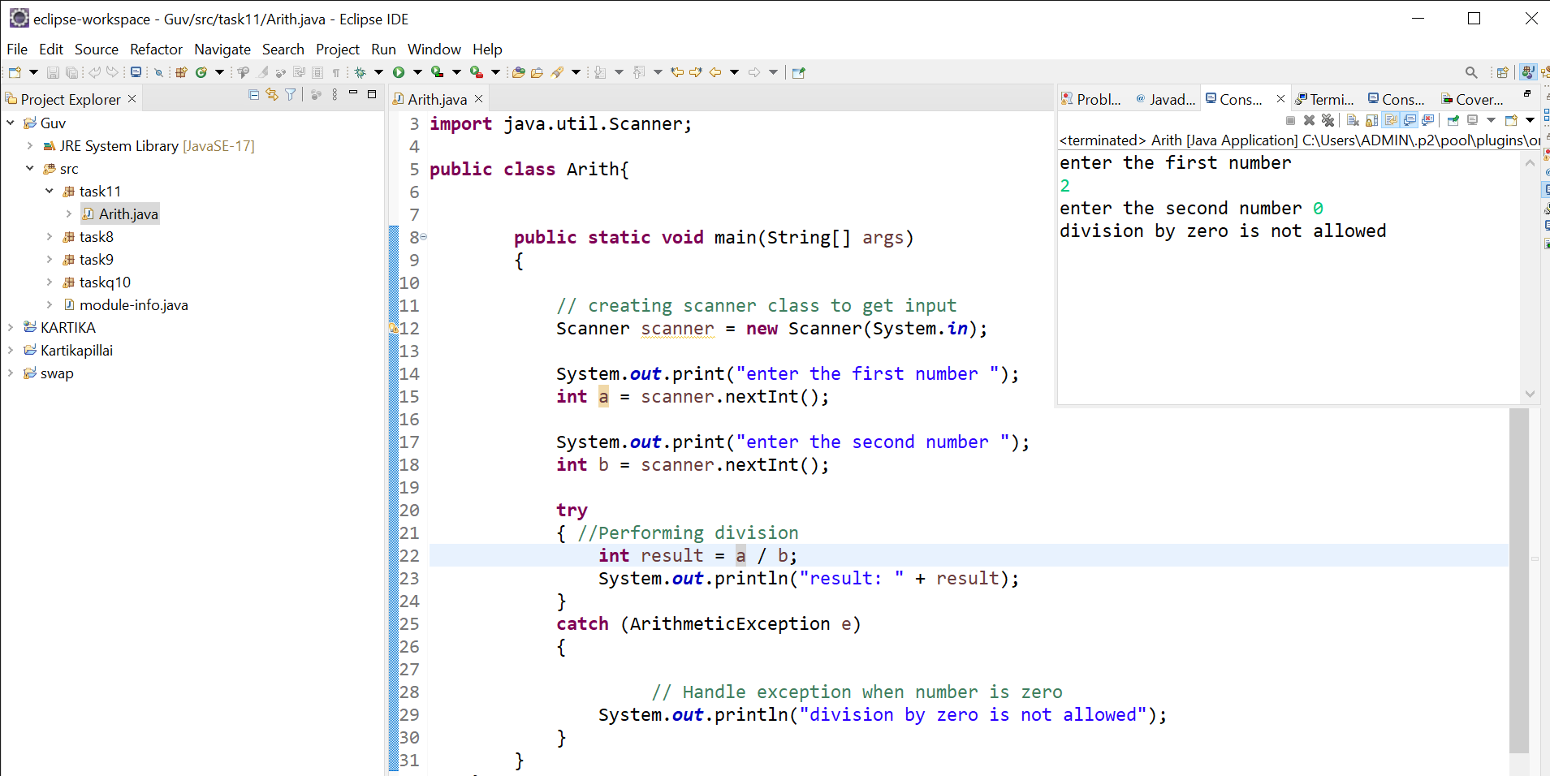

**05.ArrayIndexOutOfBound and StringIndexOutOfBound**

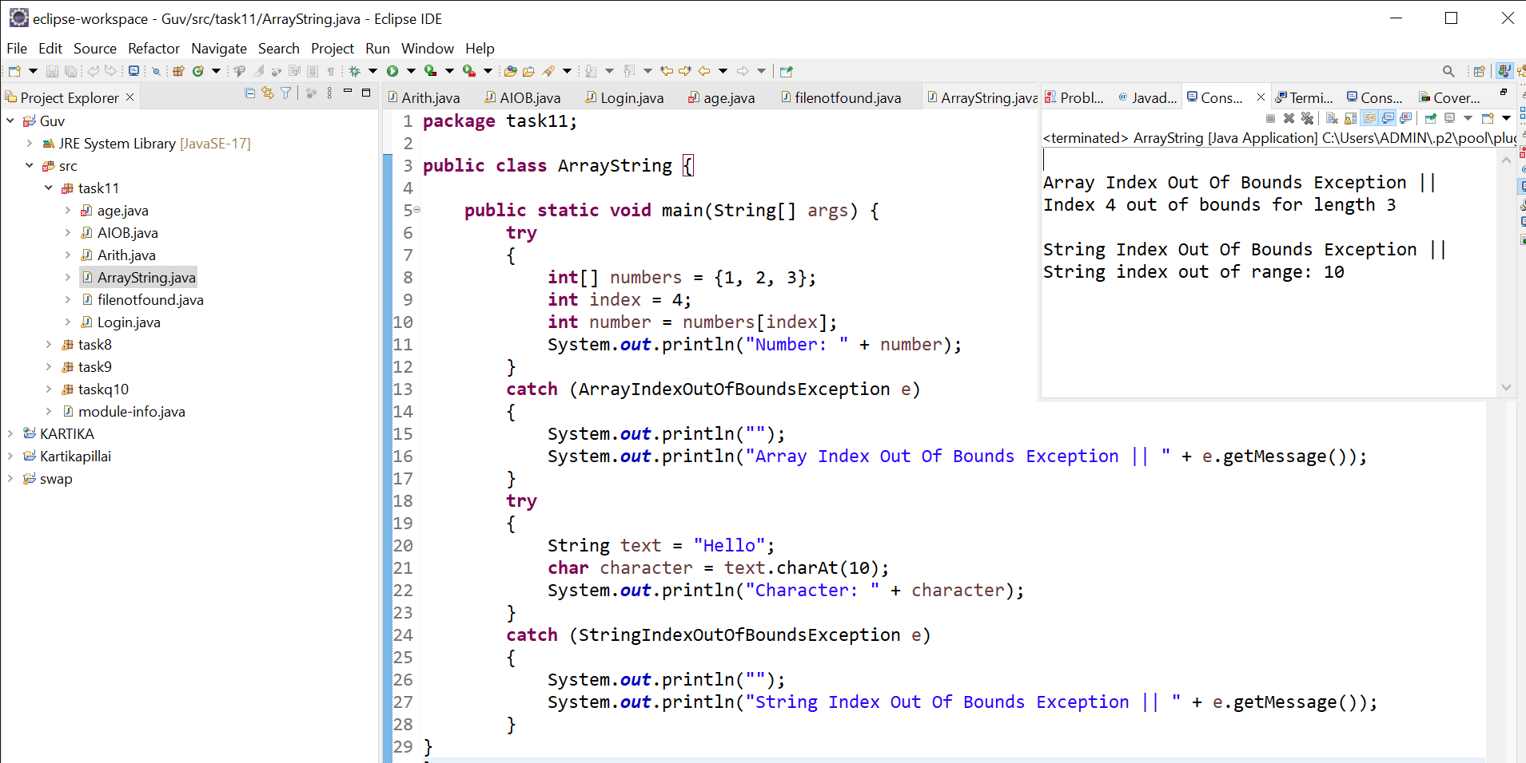

**6.Exception handling for incorrect password:**

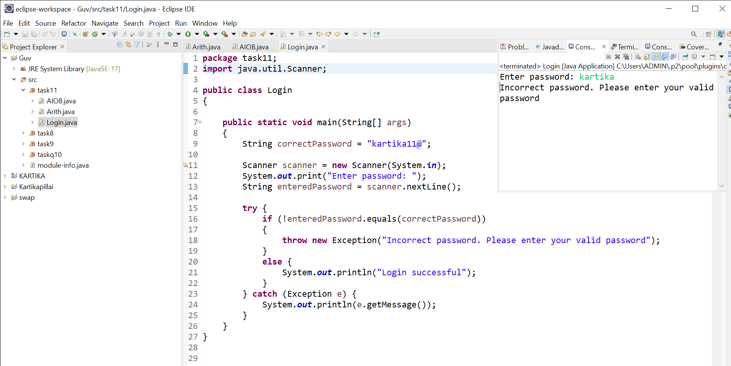

**07.InvalidAgeException:**

**8.Filenotfound error message:**

